<Insert Project Name>

Template Name

Date: <Insert Date>

Document Version: V1.1

Introduction to the Financial Feasibility Assessment 3
Part 1: Executive Financial Summary 3
The Investment Overview 3
Financial Scorecard 4
Part 2: Total Investment Cost Analysis (Outflows) 4
Initial Capital Costs (CAPEX) 4
Startup Expenses (One-Time OPEX) 5
Working Capital Requirement 5
Part 3: Revenue and Savings Projections (Inflows) 5
Revenue Generation (New Cash) 5
Cost Savings (Avoided Cash) 5
Salvage Value 6
Part 4: Recurring Operating Costs (The Offset) 6
Part 5: Cash Flow Statement (Pro Forma) 6
Part 6: Detailed Financial Metrics Calculation 7
1. Net Present Value (NPV) 7
2. Internal Rate of Return (IRR) 8
3. Payback Period 8
Part 7: Sensitivity Analysis 9
Part 8: Intangible Benefits (Non-Financial) 10
Part 9: Funding Strategy 10
Part 10: Conclusion and Recommendation 11
The Financial Verdict 11
Part 11: Step-by-Step Guide for Conducting the Assessment 11
Part 12: Glossary of Financial Terms 12
Conclusion 12

Introduction to the Financial Feasibility Assessment
While the Technical Feasibility Assessment asks "Can we build it?", the Financial Feasibility Assessment asks "Should we build it?" and, more importantly, "Will we make money if we do?"
This document is the cornerstone of the Business Case. In the private sector, the primary purpose of almost every project is to generate economic value. Even non-profit or government projects must demonstrate financial sustainability or "Value for Money." The Financial Feasibility Assessment is a rigorous mathematical analysis that projects the future financial performance of the proposed initiative. It determines whether the returns (benefits) justify the investment (costs) and the risks.
This template goes far beyond a simple budget. A budget tells you what you will spend. A Financial Feasibility Assessment tells you what you will earn, when you will break even, and what the "Time Value of Money" implies for your investment. It uses standard corporate finance metrics such as Net Present Value (NPV), Internal Rate of Return (IRR), and Payback Period.
This document is typically prepared by a Financial Analyst or a financially literate Project Manager during the Concept Phase. It is the primary document reviewed by the Chief Financial Officer (CFO) or the Investment Committee. If the numbers in this document do not stack up, the project will be rejected, regardless of how innovative the technology is.
The following sections will guide you through estimating cash flows, calculating discount rates, performing sensitivity analysis, and structuring the final financial argument.

Part 1: Executive Financial Summary
Executives often look at the summary table before reading a single word of text. This section must present the "headline" numbers clearly and concisely.

The Investment Overview
Instructions:
Provide the "Elevator Pitch" of the financial case.
- Project Name: [Insert Name]
- Analysis Period: [e.g., 5 Years (1 Year Build + 4 Years Operation)]
- Currency: [e.g., USD ($)]
- Discount Rate Used: [e.g., 10% (Corporate Weighted Average Cost of Capital)]

Financial Scorecard
Instructions:
Fill in the calculated results from the detailed sections below. This is the "Bottom Line."
Table: Key Financial Indicators
Metric | Result | Target/Hurdle | Status
Total Investment (CAPEX + Startup OPEX) | $1,500,000 | < $2,000,000 | Green
Net Present Value (NPV) | $450,000 | > $0 | Green
Internal Rate of Return (IRR) | 18.5% | > 12% | Green
Payback Period | 2.8 Years | < 3 Years | Yellow (Tight)
ROI (3-Year) | 30% | > 25% | Green
Recommendation:
[e.g., Proceed. The project exceeds all corporate financial hurdles and generates positive cash flow by Year 3.]

Part 2: Total Investment Cost Analysis (Outflows)
To calculate a return, you must first know the investment. This aggregates all money leaving the organization to start the project.

Initial Capital Costs (CAPEX)
Instructions:
List the one-time asset purchases. Refer to your CAPEX Request (Template 27).
- Land & Buildings: $0
- Equipment/Hardware: $500,000
- Software Licenses (Perpetual): $200,000
- Development Labor (Capitalized): $300,000
- Total CAPEX: $1,000,000

Startup Expenses (One-Time OPEX)
Instructions:
List the non-capitalized costs required to go live. Refer to your OPEX Estimate (Template 28).
- Training & Change Management: $50,000
- Marketing Launch Campaign: $100,000
- Legal & Consulting Fees: $50,000
- Total Startup OPEX: $200,000

Working Capital Requirement
Instructions:
Do not forget Working Capital. This is cash tied up in inventory or accounts receivable.
- Initial Inventory Purchase: $300,000
- Total Investment (Cash Outflow at Year 0): $1,500,000

Part 3: Revenue and Savings Projections (Inflows)
This section forecasts the money coming in. You must differentiate between "New Revenue" (selling more widgets) and "Cost Savings" (spending less on electricity).

Revenue Generation (New Cash)
Instructions:
If the project launches a new product, estimate sales.
- Unit Price: $100 per unit.
- Volume Forecast:
  - Year 1: 5,000 units ($500k)
  - Year 2: 10,000 units ($1M)
  - Year 3: 15,000 units ($1.5M)

Cost Savings (Avoided Cash)
Instructions:
If the project improves efficiency, calculate the savings.
- Current Process Cost: $500,000/year (10 staff).
- Future Process Cost: $200,000/year (4 staff + software maintenance).
- Net Savings: $300,000/year.

Salvage Value
Instructions:
At the end of the analysis period (e.g., Year 5), will the assets be worth anything?
- Asset: Heavy Machinery.
- Resale Value in Year 5: $50,000.

Part 4: Recurring Operating Costs (The Offset)
You cannot just count the revenue; you must subtract the cost of earning that revenue.
Instructions:
List the ongoing costs to run the new system/business line.
- Cost of Goods Sold (COGS): 40% of Revenue.
- Annual Maintenance: $50,000/year.
- Sales Commission: 5% of Revenue.

Part 5: Cash Flow Statement (Pro Forma)
This is the heart of the feasibility study. It maps the inflows and outflows over time.
Instructions:
Create a year-by-year table. (Numbers below are illustrative).
Table: Projected Cash Flow
Category | Year 0 (Build) | Year 1 | Year 2 | Year 3 | Year 4
(A) Investment Outflow | ($1,500,000) | $0 | $0 | $0 | $0
(B) Revenue | $0 | $500,000 | $1,000,000 | $1,500,000 | $1,500,000
(C) Operating Costs | $0 | ($250,000) | ($450,000) | ($650,000) | ($650,000)
(D) Net Cash Flow (B+C) | ($1,500,000) | $250,000 | $550,000 | $850,000 | $850,000
(E) Cumulative Cash | ($1,500,000) | ($1,250,000) | ($700,000) | $150,000 | $1,000,000
Analysis:
- Break-even Point: Occurs in Year 3, when the Cumulative Cash turns positive ($150,000).

Part 6: Detailed Financial Metrics Calculation
Now we apply the formulas to the Net Cash Flow row.

1. Net Present Value (NPV)
Definition:
Money in the future is worth less than money today due to inflation and opportunity cost. NPV discounts future cash flows back to today's value.
- Formula:
$$NPV = \sum \frac{Cash Flow}{(1 + r)^t} - Initial Investment$$
(Where $r$ is the discount rate and $t$ is the year).
- Calculation: Using a 10% discount rate...
  - Year 1 ($250k) becomes $227k.
  - Year 2 ($550k) becomes $454k.
  - Year 3 ($850k) becomes $638k.
  - Year 4 ($850k) becomes $580k.
  - Total PV = $1.9M.
  - Minus Investment ($1.5M).
  - NPV = +$400,000.
- Interpretation: Since NPV is positive, the project adds value to the company.

2. Internal Rate of Return (IRR)
Definition:
The annualized interest rate at which the project breaks even (NPV = 0). It represents the project's efficiency.
- Result: 18.5%.
- Interpretation: If the company can borrow money at 5% and earn 18.5%, this is a highly profitable venture.

3. Payback Period
Definition:
How long until we get our $1.5M back?
- Calculation:
  - End of Year 1: Still down $1.25M.
  - End of Year 2: Still down $700k.
  - End of Year 3: Up $150k.
- Result: 2.8 Years (Just before the end of Year 3).
- 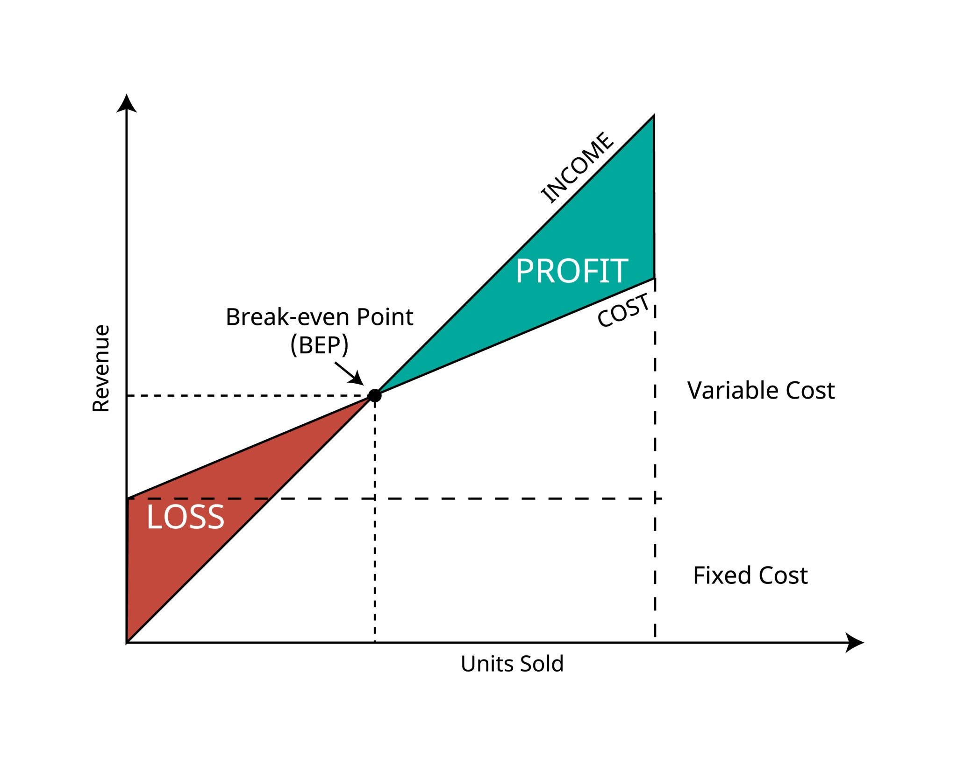
- Opens in a new window
- Getty Images
- break even point or BEP or Cost volume profit graph of the sales units and the revenue sales

Part 7: Sensitivity Analysis
The future is uncertain. This section tests how robust the financial model is against bad luck.
Instructions:
Change one variable at a time and see if the project is still profitable.
Table: What-If Scenarios
Scenario | Variable Change | Impact on NPV | Decision
Base Case | As planned | +$450,000 | Proceed
Cost Overrun | Investment increases by 20% | +$150,000 | Proceed (Still positive)
Sales Slump | Revenue decreases by 20% | ($50,000) | Stop / Re-evaluate
Delays | Launch delayed by 6 months | +$200,000 | Proceed
Finding:
"The project is highly sensitive to Revenue Volume. A 20% drop in sales turns the NPV negative. The project is relatively resilient to Cost Overruns. Therefore, the primary risk focus should be on Marketing and Sales, not Construction."

Part 8: Intangible Benefits (Non-Financial)
Sometimes a project loses money but is still "Feasible" because of non-monetary value.
Instructions:
List benefits that cannot easily be put into the spreadsheet.
- Strategic Positioning: "Entering this market establishes a foothold, preventing competitors from monopolizing the region."
- Brand Equity: "Launching a 'Green' product improves our brand image, potentially boosting sales of other products."
- Employee Retention: "Modernizing the office reduces staff turnover, saving recruitment costs (though hard to quantify exactly)."

Part 9: Funding Strategy
Where is the $1.5M coming from?
Instructions:
Identify the source of capital.
- Internal Cash Reserves: "Financed from the Retained Earnings of the parent company."
- Debt Financing: "A bank loan at 6% interest."
- Equity Financing: "Issuing new shares to investors."
- Grants: "Applying for a government R&D grant of $200k."
Impact:
If using Debt, the interest payments must be added to the Operating Costs in Part 4.

Part 10: Conclusion and Recommendation
The final verdict on the money.

The Financial Verdict
Instructions:
Select one.
- Financially Viable: NPV is positive; IRR exceeds the hurdle rate.
- Marginal: NPV is near zero; proceeds only if Strategic Benefits are high.
- Unviable: NPV is negative; the project destroys value.
Narrative:
"The assessment concludes that the project is Financially Viable. With an NPV of $450k and an IRR of 18.5%, it offers a superior return compared to leaving the cash in the bank. However, the sensitivity analysis highlights a significant risk regarding sales volume. We recommend proceeding, subject to a 'Gate Review' of the detailed Marketing Plan to ensure the sales targets are realistic."

Part 11: Step-by-Step Guide for Conducting the Assessment
Step 1: Define the "Time Horizon"
How far into the future will you look? For software, usually 3-5 years. For infrastructure (bridges, buildings), 20-30 years.
Step 2: Determine the "Hurdle Rate"
Ask your CFO: "What is our WACC (Weighted Average Cost of Capital)?" If they say 10%, you cannot approve a project that returns 8%.
Step 3: Build the Model (Bottom-Up)
Do not guess the revenue. Build it up: (Number of Customers) x (Conversion Rate) x (Price).
Step 4: Apply the "Optimism Bias" Correction
Financial models are usually too optimistic.
- Rule of Thumb: Increase costs by 20% and decrease benefits by 20% in your "Worst Case" scenario. If it is still positive, it is a great project.
Step 5: Check Tax Implications
Taxes eat profit. Ideally, calculate "After-Tax Cash Flow." (e.g., Depreciation reduces tax). Consult a tax accountant for large projects.
Step 6: Peer Review
Spreadsheet errors are common and fatal. Have a second analyst audit your Excel formulas.

Part 12: Glossary of Financial Terms
- CAPEX (Capital Expenditure): Funds used to acquire physical assets.
- OPEX (Operational Expenditure): Funds used for day-to-day running costs.
- Discount Rate: The interest rate used to determine the present value of future cash flows.
- Hurdle Rate: The minimum rate of return on a project required by a manager or investor.
- Sunk Cost: Money already spent. Never include sunk costs in a feasibility study. You decide based on future spend, not past mistakes.
- Opportunity Cost: The potential benefits an individual, investor, or business misses out on when choosing one alternative over another.

Conclusion
The Financial Feasibility Assessment is the filter that separates good ideas from profitable businesses. It provides the cold, hard logic required to safeguard the organization's resources.
By completing this template, you demonstrate financial literacy and strategic thinking. You move beyond being a project manager who just "spends the budget" to a business leader who "creates value." Remember, the goal is not to massage the numbers to get a "Yes," but to reveal the truth so the company makes the right decision.
Final Checklist for this Template:
- Is the Discount Rate clearly stated?
- Have you included both CAPEX and Startup OPEX in the initial investment?
- Is the NPV calculated correctly using the formula?
- Did you perform a Sensitivity Analysis on the key variables?
- Is the distinction between "Cash" and "Profit" clear? (Cash is king).
- Have you ignored Sunk Costs?

Meta Description:
A template for Financial Feasibility Assessment. Learn to calculate NPV, IRR, ROI, and Payback Period to determine if a project is financially viable.

